Please open a fresh Excel worksheet to explore a rolling calendar feature with Power Query.

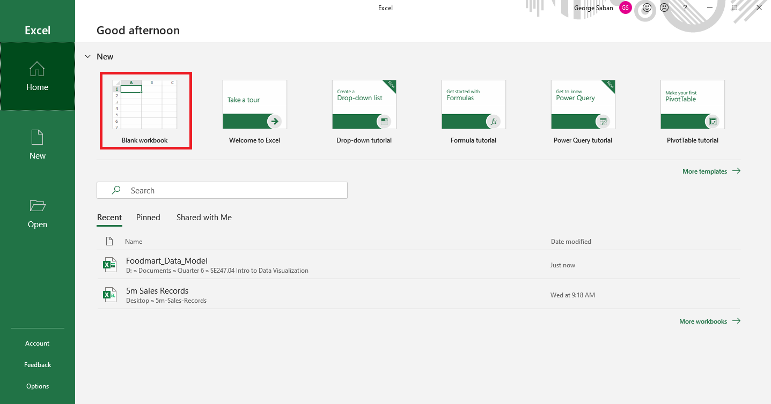

Navigate through the following: Data tab 🡪 Get Data 🡪 From Other Sources 🡪 Blank Query

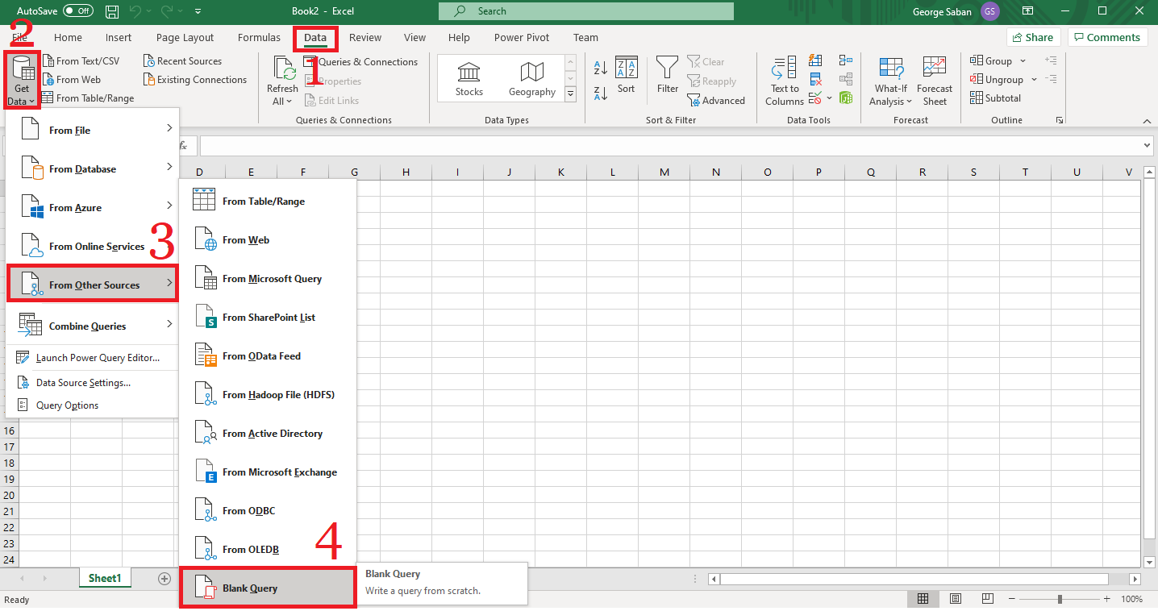

Afterwards, a blank query canvas should appear within the power query editor.

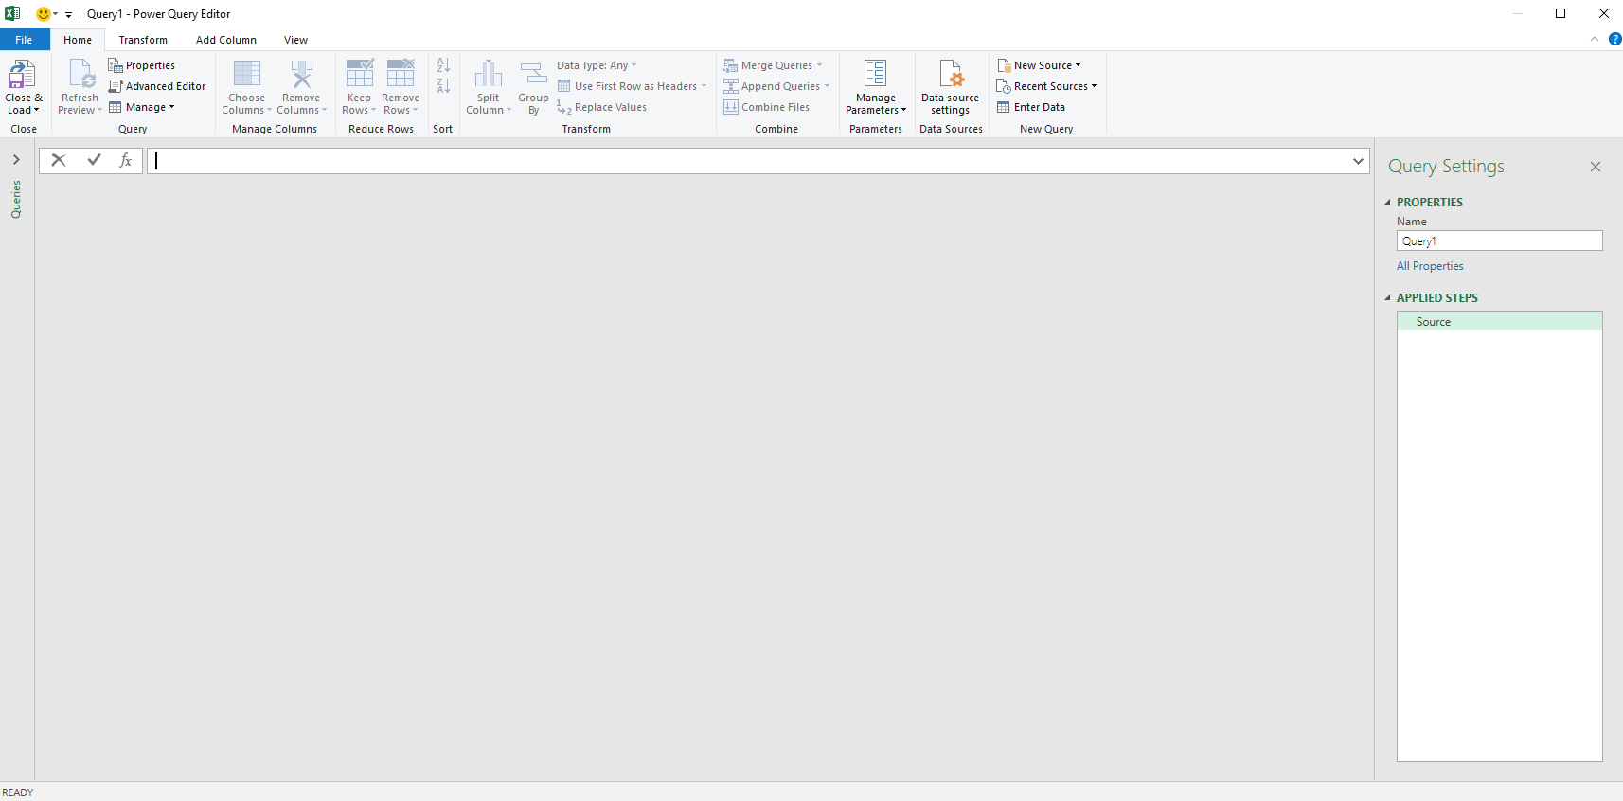

In the blank space, type the following literal M code: =#date(2017,1,1)



After pressing “enter”, the date would be printed on the screen as a one item list.

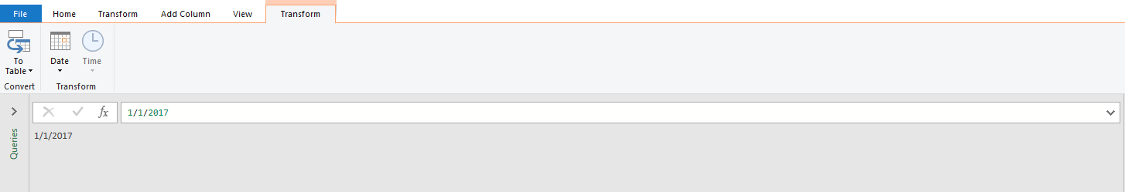

Please pay special attention to the next step or the rest of the magic of this assignment will not work.

Press 

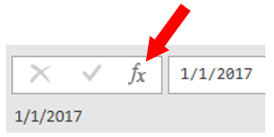

After pressing  the formula bar will display “= Source” and APPLIED STEPS will have a new entry 

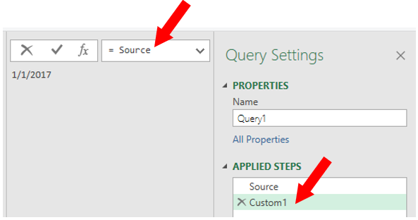

To auto-generate a list of dates, replace the “= Source” text in the formula bar, and paste the following M formula: = List.Dates(Source, Number.From(DateTime.LocalNow()) - Number.From(Source), #duration(1,0,0,0))

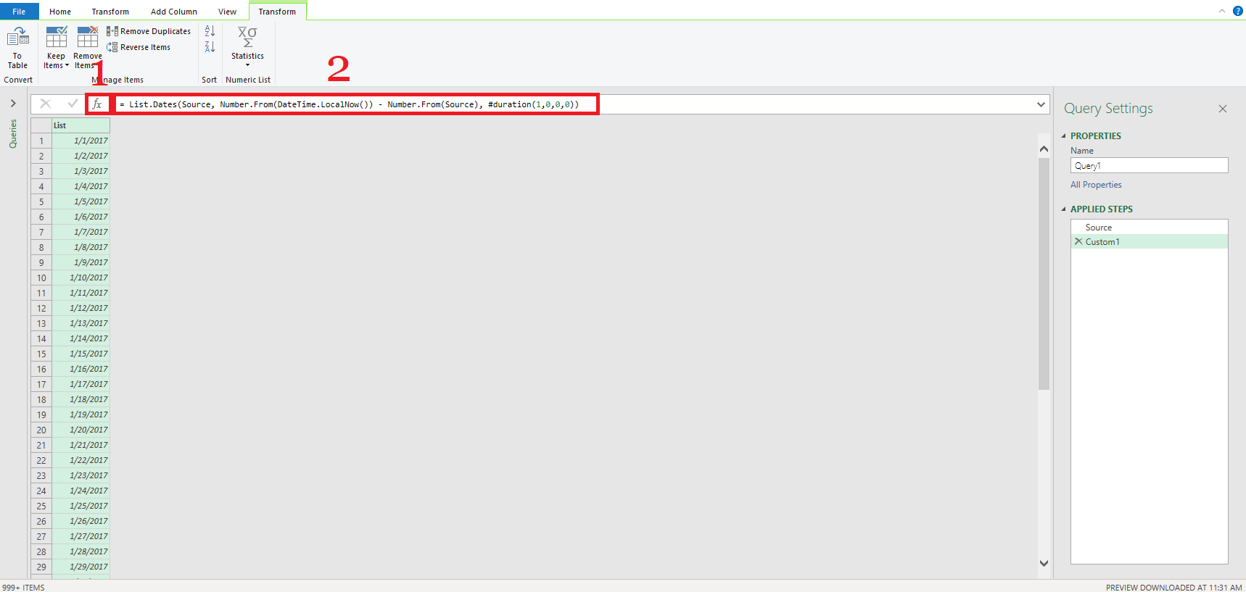

Please note: There should now be two applied steps recorded in the right-side panel.

Under the Transform navigation pane, select the “To Table” button. Then, select “OK” in the new pop-up box.

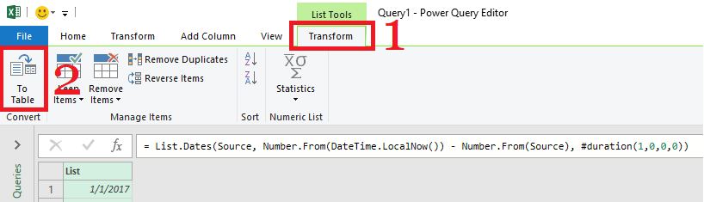

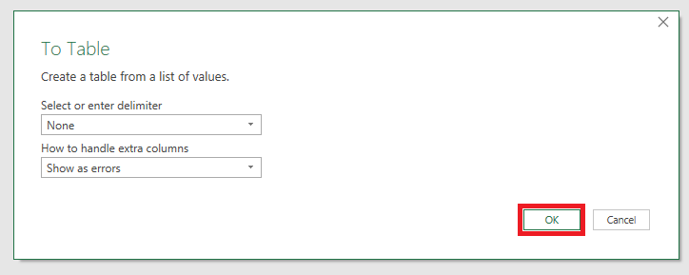

Now, the column was converted into table format.

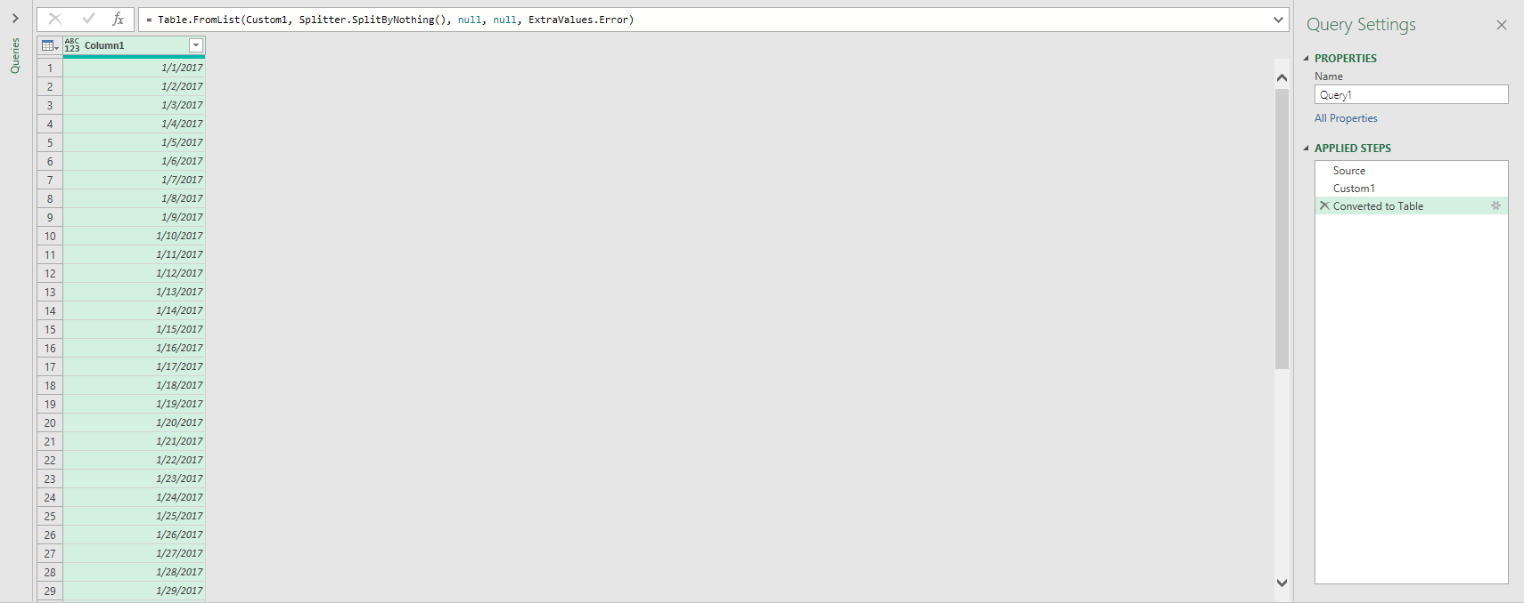

Rename the column to “Date” (via double-clicking the label or right-click 🡪 rename).

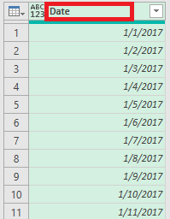

Change the data type of the column to date by pressing the “ABC 123” icon to the left of the column title, then selecting “Date”.

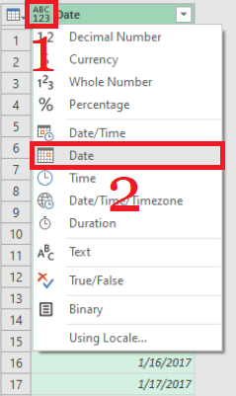

Finally, ensure that the title of the query is renamed to “Rolling_Calendar” with your first and last initials appended to the end (e.g. “Rolling_CalendarGS”).

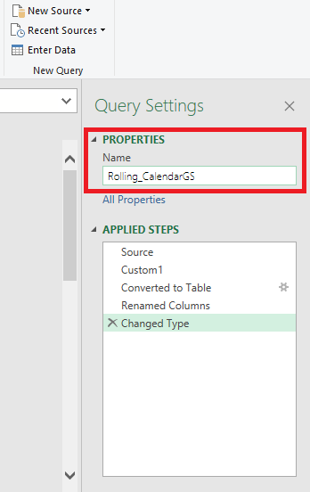

Since this is a demo, there is no need to save this query.

To submit to canvas:

1. Resize the Excel Power Query Editor and take a snapshot using Window's Snipping Tool.
2. Make sure the system's date, your name, and the M formula are included in the image (please refer to the example below).
3. Submit to Canvas in PNG format.

